**Topological Analysis of 4-dimethyl amino pyridine phthalic acid**

***Reshma J. S1, Joselin Beaula T2*.***

*1Research Scholar, Reg.No: 22213082132011, Department of Physics and Research Centre,   
Malankara Catholic College,Mariagiri-629153, Affiliated to Manonmaniam Sundaranar University, Abishekapatti-627012,Tirunelveli, Tamilnadu, India.*

*2Assistant Professor, Department of Physics and Research Centre, Malankara Catholic College,  
Mariagiri-629153, Tamilnadu, India.*

[*\*joselinbeaula@gmail.com*](mailto:*joselinbeaula@gmail.com)

**Abstract**

A new organic crystal 4-dimethyl amino pyridine phthalic acid (DAPP) was grown from slow evaporation method. Single crystal XRD was utilized to calculate the lattice constants, the molecular arrangements, and the formation of hydrogen bonds in the DAPP compound. Structural parameters, electronic properties, frontier energy gap, natural charge and population DAPP were determined by using quantum chemical density functional theory with B3LYP/6–311++G(d,p) as basis set. Employing atoms in molecules theory (AIM) to find the binding energies, ellipticity and Laplacian of the electron density projection by electron localization function (ELF) and Localized electron locator (LOL). An electron density (ED) based methodology is used to identification of inter/intra molecular interactions based on independent gradient model (IGM).

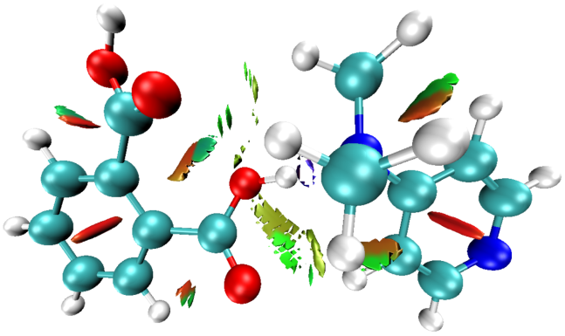 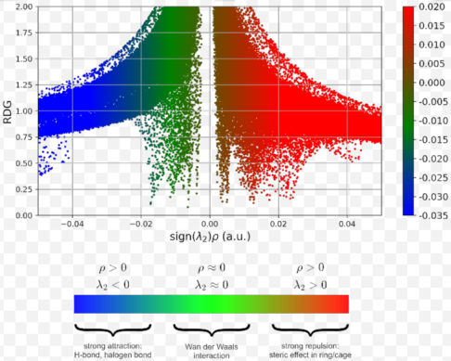

**Fig. RDG and RDG scatter plot**