1. Link the Photogallery to Downloads > Gallary

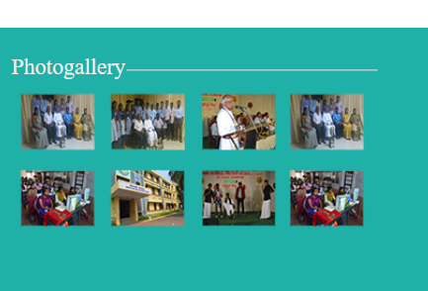

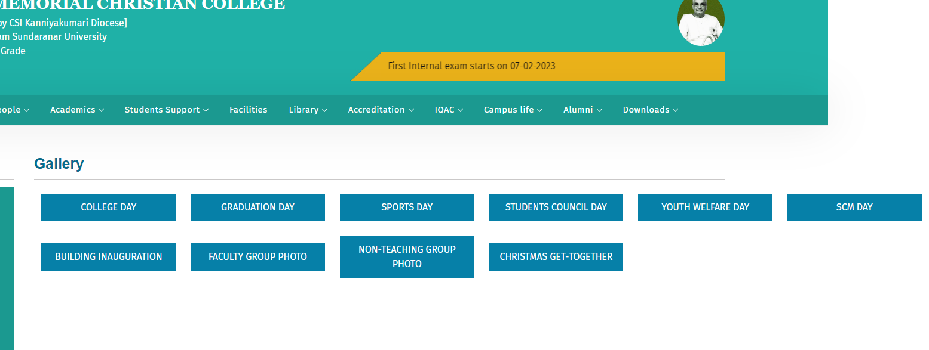

1. Staff profile > Personal - Area of interest - increase the size

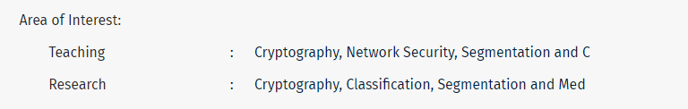

1. Academics > Department> Activities

Not displaying based on academic year – descending order

1. Students support > Youth welfare >
2. Competition rules – bullet points not displaying
3. Competition schedule - not working
4. Competition rule – must display based on **event name**
5. Committee - link Campus life> Extracurricular> Youth welfare and finance club
6. Activities – link Campus life> Extracurricular> Youth welfare and finance club
7. Trophy winners > rules bullet points not displaying
8. Academics > Departments > People > former faculty not working

---------------------------------------------------------------------------

In Admin

1. Downloads > Newspaper clipplings - needs one more line next to Title – to type paper name and page no.

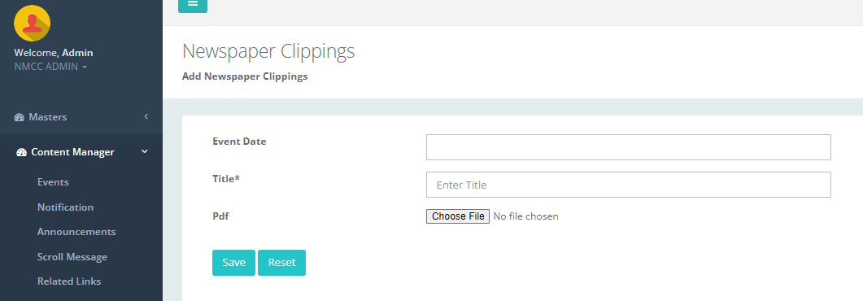

1. Departments > Activities > Search not working
2. Content Manager > Day order - search not working
3. Staff Teaching Profile > staff teaching – search not working
4. NCC – NCC officers – edit and delete not working
5. Sports – Physical director – edit and delete not working

(Physical director degree display)

Rank holders display ? - - >In home page click on any name from University Ranks tab