Studies on the physical and chemical properties of Vermicasts
Prakasam T^{1 *} and Mable Rose J²
^{1*}Assistant Professor in Zoology, ²Former PG student,
PG & Research Department Of Zoology, S.T.Hindu College, Nagercoil(Affiliated to M.S. University Tirunelveli)
*prakasamthiagarajan211@gmail.com
Abstract

Vermicasts (worm casts) are small heaps of muddy soil ejected from the digestive tract of earthworm. Vermicast is a mixture of earthworm castings and uneaten bedding and feedstock harvested from worm beds. This means that we started with organic materials for bedding and added feedstocks. The worms consumed most of the food and bedding, and left behind a mixture of their castings (worm poop) and undigested organic materials. These earthworms live in permanent vertical burrows drawing leaves and other plant debris down, a behaviour known as anecic. In most cases worm casts can be tolerated and brushed off when dry; a minor inconvenience compared to the benefits of soil aeration and nutrient recycling. On some fine lawns, such as that which is low cut for sport, and gravel paths worm casts may be considered undesirable by some gardeners. soil-dwelling animals that have elongate cylindrical segmented bodies. Adult earthworms have a distinctive thickened band, known as the clitellum. Earthworm activities are beneficial in gardens, for both soil structure and in nutrient recycling. Earthworms feed on dead plant material and in doing so ingest a certain amount of soil. As a consequence, an earthworm's excrement has a muddy consistency and appearance. Most earthworm species void waste material underground but a few species deposit casts on the surface. In most cases worm casts can be tolerated and brushed off when dry. Some gardeners collect these casts and use them as a potting medium. This can create places where mosses and lawn weeds can establish. Worm casts can be distinguished from soil brought up to the surface by other lawn animals, such as ants, mining bees and moles, by the fine muddy nature of the excreted soil. Freshly deposited worm casts often have a coiled appearance. Vermicast is a mixture of earthworm castings and uneaten bedding and feedstock harvested from worm beds. This means that we started with organic materials for bedding and added feedstocks. The worms consumed most of the food and bedding, and left behind a mixture of their castings (worm poop) and undigested organic materials. The current investigation deals with the collection of vermicasts from an area where rubber plants are grown. The physical chemical properties of earthworm castings were analysed.
KEYWORDS: Vermicasts, feedstocks, Earthworms, Anecic, Clitellum

INTRODUCTION

Vermicomposting is the term given to the process of conversion of biodegradable matter by earthworms into vermicast (Abbasi and Ramasamy, 2001). In the process, a major fraction of the nutrients contained in the organic matter is converted to more bioavailable forms .Application of vermicompost improves the soil structure by increasing porosity and reducing the bulk density .It improvises soil aeration, water-holding capacity, buffer capacity and cation exchange capacity of soil (Nada et al 2013).In addition, the vermicompost is also reported to contain biologically active substances such as plant growth regulators and have been shown to increase growth of many plants ( Sinha, 2009).

Although a considerable number of studies have been carried out on vermicomposting of various organic material with different earthworm species and their impact on the soil and plant growth (Padmavathiamma et al.,2008), there is still a lack of knowledge on the change in the properties of vermicast during the course of storage. The castings of anecics and endogeics have been extensively studied in relation to the changes in the physico-chemical properties during ageing process (Mariani et al., 2007). There are also few studies on the enzymes and microbial aspects of castings generated from the epigeic earthworms (Scullion et al.,2003).
Application of biofertilizer for crop production is environmental friendly and sustainable for ecological system. Several time of biofertilizer have been developed from bacterial, particularly Rhizobiumspecies, Azospirillum species Azotobacter species and used in the production of various plants (Marisa Phiromtan et al., 2013). Biofertilizers are defined as preparations containing living cells or latent cells of efficient strain of microorganisms that help crop plant uptake of nutrients by their interaction in the rhizosphere when applied through seed or to soil. Biofertilizer from nitrogen fixing bacteria come in three forms: liquid, solid and lyophilized. For liquid and lyophilized ones, only solution medium is used, but for solid form, carries such as peat, activated charcoal and chicken dung are needed. Azotobacter is a free living nitrogen fixing bacteria is a beneficial biofertilizer which has profitable effect on plant and soil fertility. Azotobacter is gram-negative, motile, pleomorphic aerobic bacterium which produces catalase, oval or spherical that form thick cysts and may produce large quantities of capsular slime (Gomare KS et al,2013)

A revolution is unfolding in vermiculture studies for vermicomposting of diverse organic wastes by waste eater earthworms into a nutritive ‘organic fertilizer’ and using them for production of ‘chemical –free safe food’, both in quantity & quality without recourse to agro-chemicals. Heavy use of agro-chemicals since the ‘green-revolution’ of the 1960’s boosted food productivity, but at the cost of environment & society. It killed the beneficial soil organisms & destroyed their natural fertility, impaired the power of ‘biological resistance’ in crops making them more susceptible to pests & diseases. Chemically grown food have adversely affected human health. The scientific community all over the world is desperately looking for an ‘economically viable, socially safe & environmentally sustainable’ alternative to the agro-chemicals.

Vermicomposts work as a ‘slow –release organic fertilizer’. With their continued application the ‘organic nitrogen’& other nutrients in compost tends to be released at constant rate from the accumulated ‘humus’ and the net overall efficiency of NPK over a period of years in considerably greater than 50% of that of chemical fertilizers. Our study shows that it can promote growth from 50 to 100% over conventional compost & 30 to 40% over chemical fertilizers besides protecting the soil and the agro-ecosystem while producing ‘nutritive and tasty food’ at a much economical cost atleast 50-75% less as compared to the costly chemical fertilizers. Study found that maximum benefit from vermicompost is obtained when it constitutes between 10 to 40% of the growing medium (Arancon N, 2004).

The best part is that the use of earthworms and vermicompost in farm production provides dual-benefit to crops. While promoting excellent growth it also protects the crops from pests and diseases and thus significantly reduce the use of chemical pesticides.

OBJECTIVES OF THE PRESENT STUDY

- To collect vermicastings from a selected site for monthly once for a duration of five months.
- To study the physico-chemical properties of vermicastings collected month wise for a duration of five months.
- To calculate mean and standard deviation for the collected vermicastings in relation to physico-chemical properties.

MATERIALS AND METHOD

SELECTION OF STUDY AREA

This is a rubber plantation area having plenty of rubber trees(Plate 1).

IDENTIFICATION OF VERMICAST

Vermicast is an excretory product of earthworm. Early morning Vermicast can be observed by the projection or mount which appears on the soil (Plate 2).

COLLECTION OF VERMICAST

Every month 1st Sunday early morning vermicast are collected from different places in the rubber plantation area and mixed then stored in a poly bags.

PHYSICO-CHEMICAL ANALYSIS OF VERMICAST

The collected vermicast monthwise is analysed for various physico – chemical parameters such as pH, EC, macro nutrients like Nitrogen , Phosphorus, Potassium and micro nutrients like Iron, Manganese, Zinc and copper.

STATISTICAL ANALYSIS

The collected vermicastings of five months data for various physico-chemical parameters were statistically calculated for mean and standard deviation.

RESULT

pH

pH of the vermicastings ranges from 7 to 6.5 and the mean pH is 6.7 and SD is 0.17.

ELECTRICAL CONDUCTIVITY (Ec/dsm⁻¹)

Ec ranges from 0.23 to 0.35 with a mean of 0.3 and SD is 0.14 in the vermicastings.

MACRONUTRIENTS

NITROGEN (%/Acre)

Vermicastings nitrogen ranges from 1.65% to 3.11% per acre with a mean of 2.4% per acre and a SD of 0.47.

PHOSPHORUS(%/Acre)

Phosphorus content is vermicastings ranges from 0.48% to1.06% per acre with a mean of 0.7% per acre and a SD of 0.35.

POTASSIUM(%/Acre)

Potassium content in vermicastings ranges from 1.39% to 2.27% per acre with a mean of 1.8% per acre and a SD of 0.2.

MICRONUTRIENTS
IRON (Fe)

Iron (Fe) content in the vermicastings ranges from 32.16 to 19.61ppm with a mean of 23.9 ppm and SD is 4.6.
MANGANESE (Mn)

Manganese (Mn) content in the vermicastings rangs from 11.41 to 9.31 ppm with a mean value of 10ppm and SD is 0.76.

ZINC (Zn)

Zinc (Zn) content in the vermicastings ranges from 12.48 to 11.04 ppm and the mean is 9.9 ppm and SD is 2.

COPPER (Cu)

Copper (Cu) in vermicastings ranges from14.25 to 11.2 ppm with a mean value of 10.8ppm and SD is 2.1.

DISCUSSION

Earthworms restore & improve soil fertility and boost crop productivity by the use of their excretory product –‘vermicast’. They excrete beneficial soil microbes, and secrete polysaccharides, proteins and other nitrogenous compounds into the soil. They promote soil fragmentation and aeration, and bring about ‘soil turning’ and dispersion in farmlands. Worm activity can increase air-soil volume from 8-30%. One acre of land can contain up to 3 million earthworms the activities of which can bring up to
8-10 tons of ‘top soil’ to the surface (in the form of vermicast) every year. Presence of worms regenerate compacted soils and improves water penetration in such soils by over 50%. U.S. study indicate that 10,000 worms in a farm plot provides the same benefit as three farmers working 8 hours in shift all year round with 10 tons of manure applied in the plot (Li, K.M. ,2005)

Indian study showed that an earthworms population of 0.2-1.0 million per hectare of farmlands can be established within a short period of three months. On an average 12 tons/hectare/year of soil or organic matter is ingested by earthworms, leading to upturning of 18 tons of soil/year, and the world over at this rate it may mean a 2 inches of fertile humus layer over the globe (Bhawalkaret al.,1993).

Worm castings, also known as vermicast, are a worm’s manure in its natural form. The waste produced by worms as they eat compost, natural decaying debris in soil, and other organisms such as rotifers, nematodes, protozoans, bacteria, and fungi becomes a nutrients-rich soil additive.

Worm castings contain an abundance of bacteria, remnants of decaying plant matter, enzymes, earthworm cocoons, and other by- products. The manure is high in Magnesium, Nitrates, Phosphorus, Potassium, Zinc, Borax, Iron, Carbon, Calcium, Copper, Cobalt, and Nitrogen.

Worm castings are generally a dark brown in clolur and football-shaped. When added to the soil they improve soil aeration and increase the soil’s water-retention abilities.

Worm castings are a highly coveted natural fertilizer because the nutrients are readily available to the plant and the castings do not burn or harm the plant’s delicate root system.

As the manure moves through the worm’s digestive tract, a thin layer of mucus starts to encase the manure particles. The mucus helps preserve the worm castings so they slowly release their abundant nutrients into the surrounding soil over a period of about two months.

In this investigation pH of worm castings is neutral at a pH level of 7. The manure is odorless. Each worm casting also contains high levels of humic acid, which helps accelerate a plant’s overall growth rate.

The mass of processed soil particles voided by the earthworm is called vermicast. The worm casts are also called vermicasts or worm castings. It is different from vermicompost.

The worm casts are made in the intestine of earthworms. The earthworms swallow the soil with organic manure. They are ground in their gizzard and digested their intestine by the addition of enzymes and mucous. Only 10% of the swallowed materials are absorbed. The remaining 90% is voided out. The undigested wastes pass out through the anus as worm casts. They are deposited on the mouth of the burrows as well as inside the burrows. The quality of casts varies according to the region, season, type of soil and species of worms. More casts are produced during the wet monsoon seasons than other seasons. The amount of soil turned over by earthworm depends on species and geogarphical location.

The worm casts are of four different shapes. They are:

1. Fine powder
2. Pellets
3. Cylindrical rods
4. Coiled threads

Certain worm casts are fine soil-like. They take the form of pyramids in the mouth of the burrows.

Eg: Endrilus eugeniae , an Africa species produces casts in the form of fine soil that take the form of pyramids.

Pellets are granular worm casts and are spherical or oval in shape.

Eg: In Pheretimaposthuma, the worm casts are in the form of pellets. In Indian species, such as Metaphire posthuma, Hoplochaetella suctoria, Eutyphoeus incommodus and E. nicholsoni the casts are oval or spherical in shape.
In some species of earthworms, the worm casts are in the form of short, cylindrical rods.

Eg: The casts are cylindrical in Curgiona narayani and Thatonia species.

The coiled threads are continuous and coiled.

Eg: Eutyphoenus waltonian Indian worm, produces casts in the form of twisted coiled threads.

The worm casts are odourless, noticed in our present study.

They have a neutral pH of 7, relates to our study where the pH is slightly acidic, 6.7 to near neutral.
The worm casts contain minerals, hormones, vitamins, enzymes, mucous moisture, antibodies and microbes.

The minerals present in the casts are of two types namely macronutrients and micronutrients.

The micronutrients include Manganese, Boron, Zinc, etc. In our study also we tested for Mn and Zn.

The macronutrients include Carbon, Nitrogen, Potassium, etc.

The castings contain high amounts of nitrogen, potassium, phosphorus is also noticed in our study.

Normally castings contain:

5 times more nitrogen than surrounding soil, suits our study.
7 times more phosphates than surrounding soil, relates to our investigation.
11 times more potash than surrounding soil, also noticed in our study.
1.5 times more calcium than surrounding soil.

Casts contain enzymes such as protease, amylase, lipase, cellulase, andchitinase.These enzymes continue to disintegrate organic matter even after they have been excreted. The worm casts contain a thick population of microbes. These microbes include nitrogen fixers also. In the worm casts, they multiply and produce a thick population. The worm casts contain hormones like auxins gibberellins, etc., The mucus secreted by the earthworm is also present in the worm casts.

The vermicast is a very good organic fertilizer and soil conditioner.
Worm casts are good organic manure.
They improve soil fertility.
They increase aeration in the soil.
They provide porosity to the soil.
They improve moisture holding capacity of soil.
The worm casts contain bacteria. They continue the composting process in the soil. The earthworm casting, along with the natural tillage by the burrowing action of the worms, enhances the permeability of water into the soil.
The water holding capacity of worm castings is 9 times greater than that of natural soil. (Ismail,2005)
CONCLUSION AND RECOMMENDATION

From the present investigation it is very clear that vermicastings is a natural, and readily available nutrients for growth of plants.

Vermicast is a good organic manure, soil conditioner. It improves soil fertility, aeration and porosity.

Vermicast also contains many types of microorganisms such as bacteria, fungi, protozoans, etc., which releases many substances which are vital for the growth of plants noticed in this investigation.

The use of organic manures such as Vermicomposts, vermicasts greatly improves the soils physico-chemical properties. So this type of practises can go for a Sustainable Agriculture known as Organic Farming is the need of the hour vermicast improves the soils health and wealth.
SUMMARY

- The study area is rubber plantation having plenty ofrubber trees.
- The excretory product of earthworm is vermicastwhich can be observed by a projection or mount appearing on the soil.
- Every month first Sunday morning vermicast was collected from different regions of rubber plantation and mixed, later stored in a ploy bag.
- The collected vermicast month wise is subjected for various physic-chemical parameters such as pH, Electrical conductivity and Macronutrients like Nitrogen, Phosphorus, Photassium and Micronutrients like Iron, Manganese, Zinc and Copper.
- For a duration of five months vermicastings physico-chemical properties were
- From the present study reveals that Vermicast have a good amount of NPKand also an amicable pH which is good for plant growth .
- Vermicast is a good organic manure for a Sustainable Agriculture.
Plate 1: Study area having plenty of rubber trees

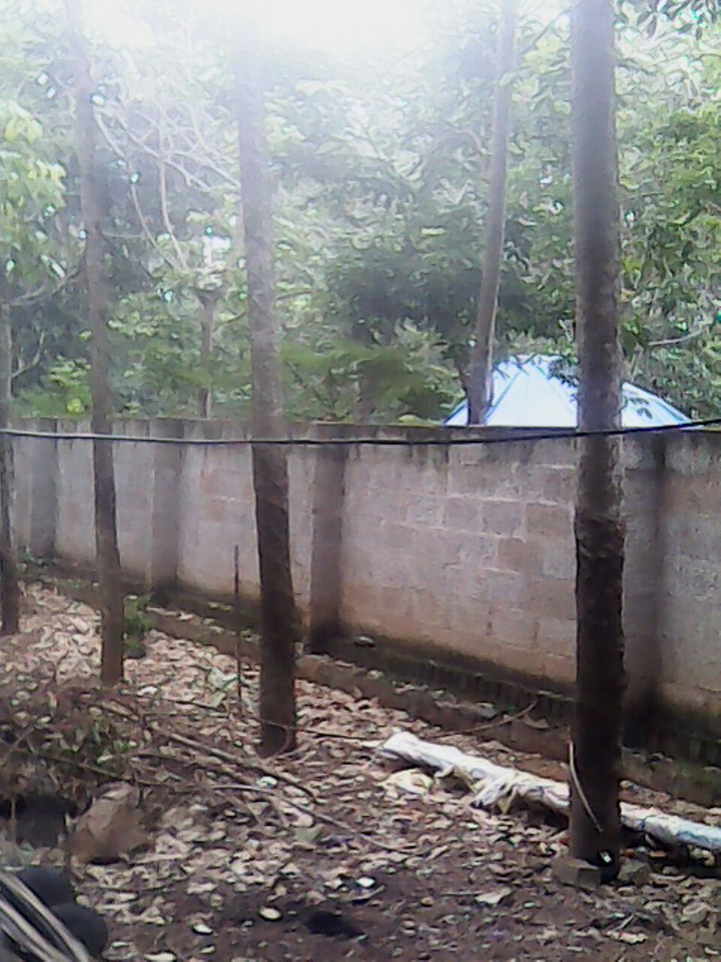

Plate 2: Vermicast-Pellet form
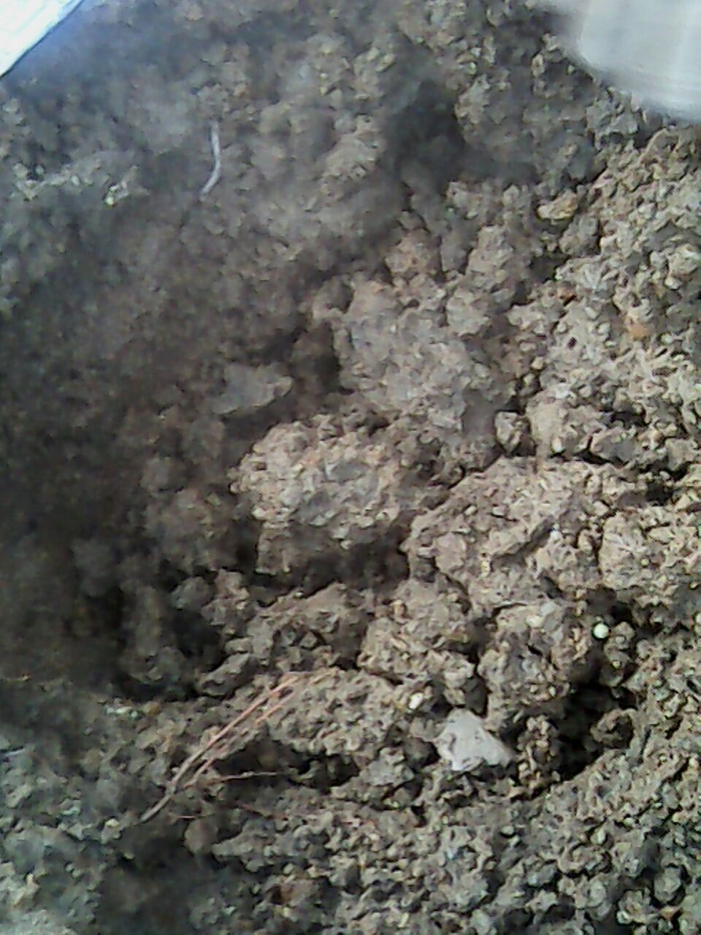

Table 1
Physico - Chemical analysis of Vermicast

 | Sample 1 | Sample 2 | Sample 3 | Sample 4 | Sample 5 | Mean | Standard Deviation
PH | 7 | 6.6 | 6.7 | 6.5 | 6.8 | 6.7 | 0.17
Ec / dsm⁻¹ | 0.35 | 0.34 | 0.23 | 0.3 | 0.31 | 0.3 | 0.14
N (%/Acre) | 1.65 | 2.59 | 3.11 | 2.47 | 2.44 | 2.4 | 0.47
P (%/Acre) | 1.06 | 0.48 | 0.72 | 0.64 | 0.7 | 0.7 | 0.35
K (%/Acre) | 1.39 | 1.65 | 2.27 | 1.8 | 1.97 | 1.8 | 0.2
Fe (ppm) | 32.16 | 25.8 | 19.61 | 20.08 | 22.24 | 23.9 | 4.6
Mn (ppm) | 11.41 | 9.31 | 9.67 | 10.21 | 9.44 | 10 | 0.76
Zn (ppm) | 12.48 | 11.96 | 11.04 | 11.82 | 12.22 | 9.9 | 2
Cu (ppm) | 13.01 | 14.25 | 11.8 | 13.05 | 11.2 | 10.8 | 2.1
Fig. 1

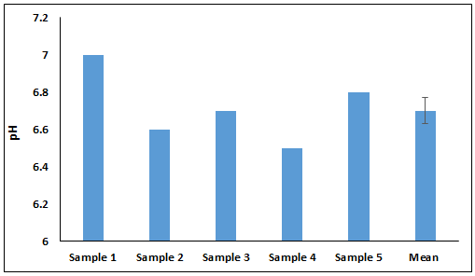

Fig. 2

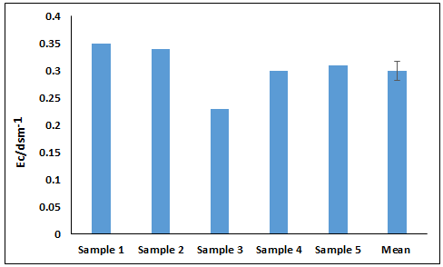

Fig. 3

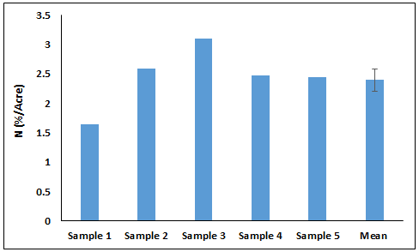

Fig. 4

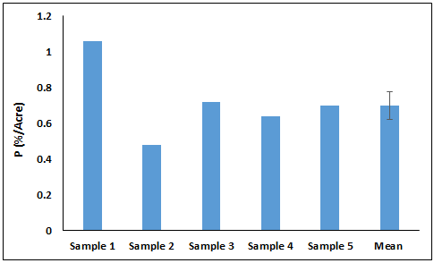

Fig. 5

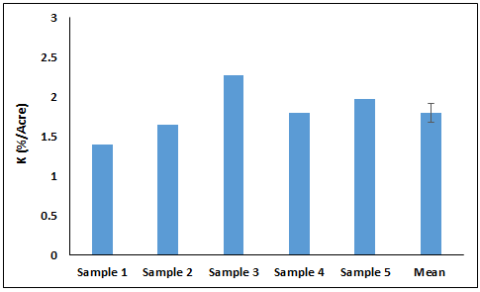

Fig. 6

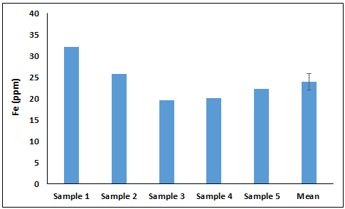

Fig. 7

v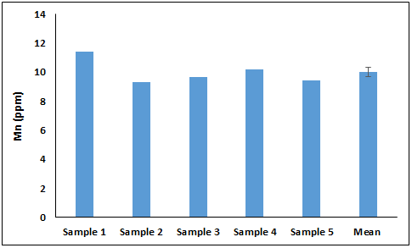

Fig. 8

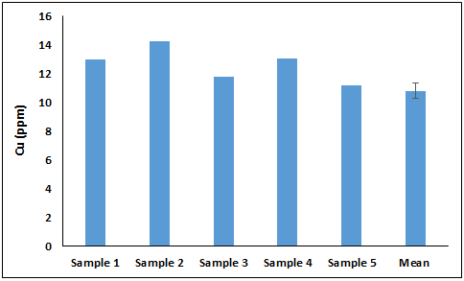

Fig. 9

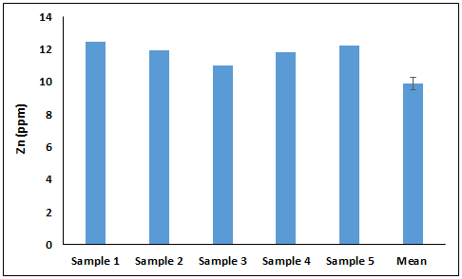

References
Abbasi, S.A and Ramaswamy, E.V, 2001. Solid waste Management with earthworms. Discovery Publishing House, New Delhi.p178.

Arancon, 2004 An interview with Dr Norman Arancon. Casting Call 9(2).

Bhawalkar and Bhawalkar 1993. Vermiculture: The bionutrition system. National seminar on digestion technology for sustainable agriculture. IARI NewDelhi,1-8.

Gomare, Mese, Shetkar, 2013. Isolation of Azotobacter and cost effective production of biofertilizer. IJAR, 3(5): 54-56.

Li. 2005. Vermiculture industry in circular economy, worm Digest.

Ismail, S.A, 2005. The earthworm book. Other India Press. 92p.

Mariani, Jimenez, Torres, Amezquita and Decaens, 2007. Rainfall impact effects on ageing casts of a tropicaln anacic earthworm. Eur.J.Soil.Sci., 58: 1525-1534.

Marisa, Mala, Srinives 2013. Effect of various carriers and storage temperatures on survival of Azotobacter vinelandii. Mod.App.Sci,7(6):81-89.

Nada, Rensbutg, Classens and Blumenstein, 2011.Effect of vermicompost on soil and plant properties of coal spoil in the Lustain Region (Eastern Germany). commun. Soil.Sci. Plant Anal., 42: 1945-1957.

Padmavthiammma, Li, Kumari, 2008. An experimental study of vermi-biowaste composting for agricultural soil improvement. Biores. Technol.,99: 1672-1681.

Scllion, Goodcare, Elliot, Huang, 2003. Food quality and microbial suceesiion in ageing vermicasts. Pedobiologia,47: 888-894.

Sinha, 2009. Earthworms: the miracle of nature ( Charles Darwins unherlded soldiers of mankind & farmers friends). Environmentalists, 29: 339-340.

