**Trinary metal oxide doped with activated carbon: synthesis and characterization for the purpose of eliminating pollution.**

P. S. Abithaa, S. Grace Victoriab

aResearch Scholar, Reg.Number: 20113282132011, bAssistant Professor

a, bDepartment of Physics & Research Centre, Women’s Christian College,

Nagercoil- 629001, Tamil Nadu, India

(Affiliated to Manonmaniam Sundaranar University, Abishekapatti, Tirunelveli-627012, TamilNadu, India)

Email: [*abithafranklin@gmail.com](mailto:*abithafranklin@gmail.com)

**Abstract:**

Water pollution carries grave consequences for both human well-being and the sustainability of ecosystems. Employing efficient sewage treatment systems is crucial in combating contamination. This investigation delves into the breakdown of phenolic pollutants using an innovative composite material consisting of activated carbon (AC) and ZnO/CuO/CdO. The porous nature of AC boosts the absorption of organic pollutants, facilitating their transfer to the light-sensitive surface of ZnO/CuO/CdO for decomposition through light exposure. Analyses of structure and composition were conducted using X-ray diffraction (XRD), Fourier-transform infrared spectroscopy (FTIR), scanning electron microscopy (SEM), and energy-dispersive X-ray spectroscopy (EDAX). UV-visible spectrophotometry was utilized to gauge the composite's efficacy in breaking down phenolic compounds under natural sunlight. The findings showcase the composite's remarkable effectiveness in phenol decomposition, harnessing AC's capabilities in removing pollutants and the photoactive properties of ZnO/CuO/CdO. This study enhances comprehension of the composite's characteristics and contributes to sustainable freshwater management by proposing environmentally friendly methodologies for sewage treatment.

**Keywords:** Activated carbon, ZnO/CuO/CdO, Activated Carbon Composite, Phenolic Degradation, Wastewater Treatment.

**1.INTRODUCTION**

Since water makes up most of the surface of the Earth and is abundant, it is essential to both the environment and human bodies, accounting for around 65% of total body mass. [1]. Water pollution, however, poses a serious risk to aquatic ecosystem diversity as well as human health. Hazardous materials are introduced into water bodies by a variety of activities, such as mining and urbanization. Water contamination is greatly increased by the widespread use of phenol and its derivatives in the chemical and petrochemical industries. For the protection of the public's health and the environment, effective management techniques are essential. Animal and human exposure to phenol can have serious repercussions, which emphasizes the necessity of effective water treatment techniques. Despite obstacles including the restricted use of visible light and environmental concerns, photocatalytic degradation—which uses metal oxide catalysts like TiO2, CdO, and ZnO—holds promise for cleaning up phenol-contaminated wastewater. Because of its large surface area and porous structure, activated carbon (AC) improves photocatalytic reactions. Organic contaminants are effectively removed from wastewater by using AC in conjunction with metal oxides such as ZnO, CuO, and CdO. Using methods like energy-dispersive X-ray spectroscopy (EDAX), scanning electron microscopy (SEM), Fourier-transform infrared spectroscopy (FTIR), X-ray diffraction (XRD), and UV-visible spectrophotometry, thorough analyses validated the composite's chemical and structural properties and evaluated its photocatalytic activity. These results provide important new understandings of the characteristics of the composite and its real-world use in wastewater treatment situations.

**2.Synthesis of AC-ZnO/CuO/CdO Nanoparticles**

Two grams of activated carbon (AC) were put to a 250 ml round-bottomed flask containing 0.5M zinc acetate (50 ml DIW) and 1M NaOH (10 ml DIW). To make sure the liquid was homogenized, it was stirred for two hours. After that, a slow addition of copper acetate solutions in different concentrations was made over the course of an hour, starting with the slow addition of 25 ml of cadmium acetate solution. The resultant precipitate was filtered, cleaned, and then dried at 80°C for 24 hours before being sintered for 2 hours at 400°C. As shown in Fig.1, this procedure yielded four samples with the labels AC/ZnO/CuO/CdO.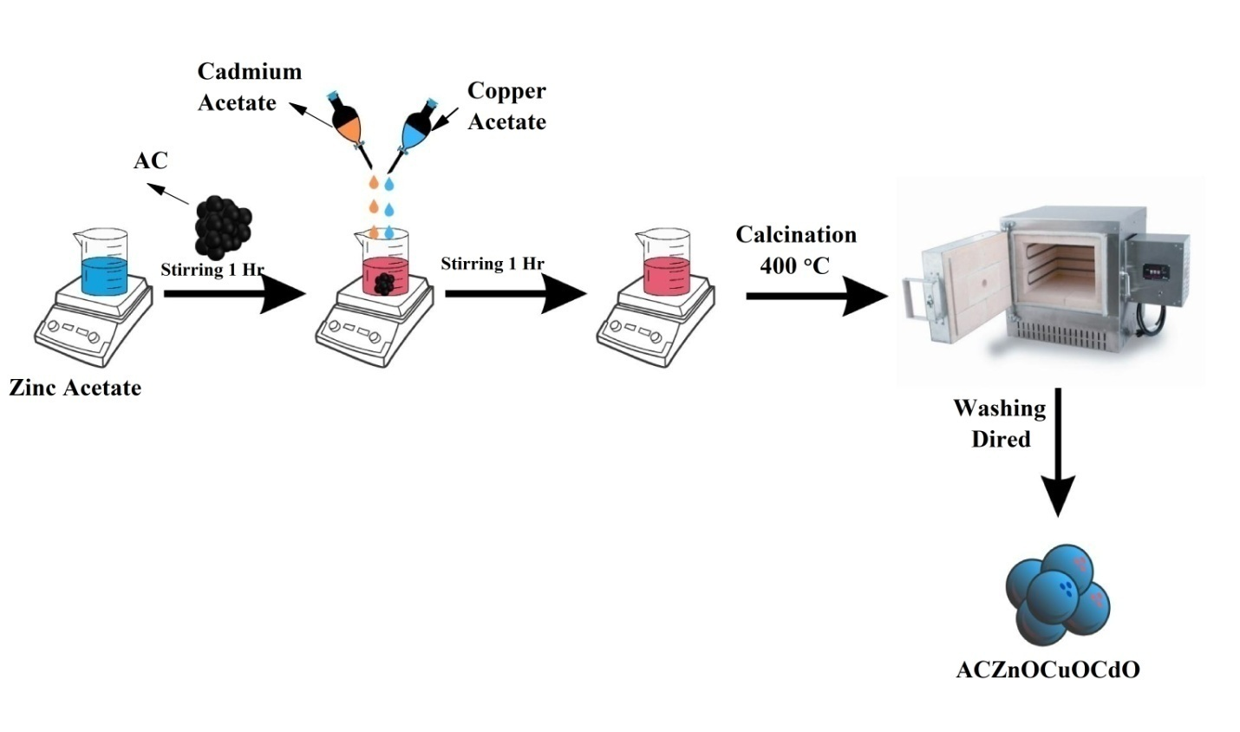

**Fig.1. Preparation of ACZnOCuOCdO nanoparticles**

**3 RESULT AND DISCUSSION**

**3.1 XRD**

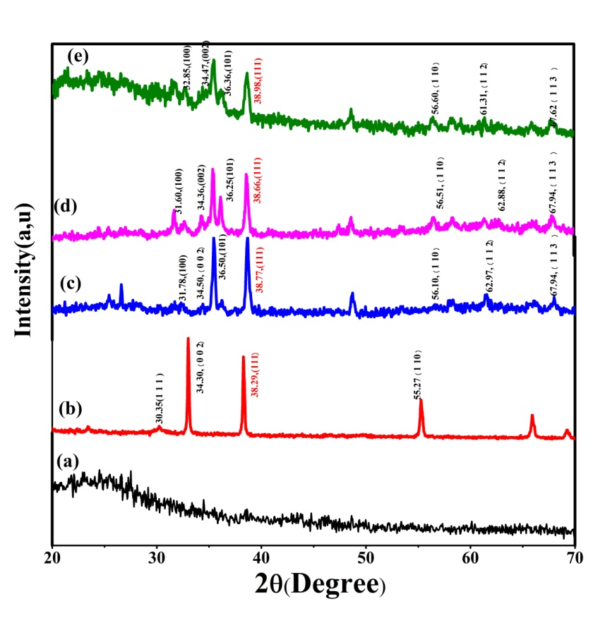

**Fig.2.XRD spectra of (a) AC , (b) AC/ZnO/CuO/CdO1, (c) AC/ZnO/CuO/CdO2, (d) AC/ZnO/CuO/CdO3 and (e) AC/ZnO/CuO/CdO4**

The structure of activated carbon (AC) and AC/ZnO/CuO/CdO composites was shown by the X-ray diffraction (XRD) pattern shown in Fig. 2. With prominent peaks at 22–24°, the amorphous shape of the AC suggested the existence of disordered carbon atoms that were favorable for adsorption. It was confirmed that the composites included zinc oxide (ZnO), copper oxide (CuO), and cadmium oxide (CdO), with peaks matching JCPDS card numbers 36–1451 [2] for ZnO, 89-5896 for CuO[3], and 05-0640 for CdO[4]. Within the CdO/ZnO/CuO nanocomposite, ZnO's unique lattice characteristic indicated a tight intra-granular interaction with copper oxide. The increased photocatalytic activity was shown by this enhanced semiconductor coupling, which was especially noticeable in AC/ZnO/CuO/CdO3. For ZnO, CuO, and CdO, the lattice values matched the corresponding crystallographic planes. These findings highlight activated carbon's potential as a catalyst support to improve photocatalytic processes.Top of Form

**3.2. SEM and EDAX analysis**

At varying concentrations, the AC/ZnO/CuO/CdO composite has an uneven and aggregated look that provides important information about its structural organization. Complete surface coverage is ensured by the effective deposition of zinc oxide, copper oxide, and cadmium oxide onto the flake-like structure of activated carbon, which forms long particles that coalesce. The existence of carbon, oxygen, zinc, copper, and cadmium is confirmed by EDX analysis; higher amounts of copper and cadmium improve catalytic properties.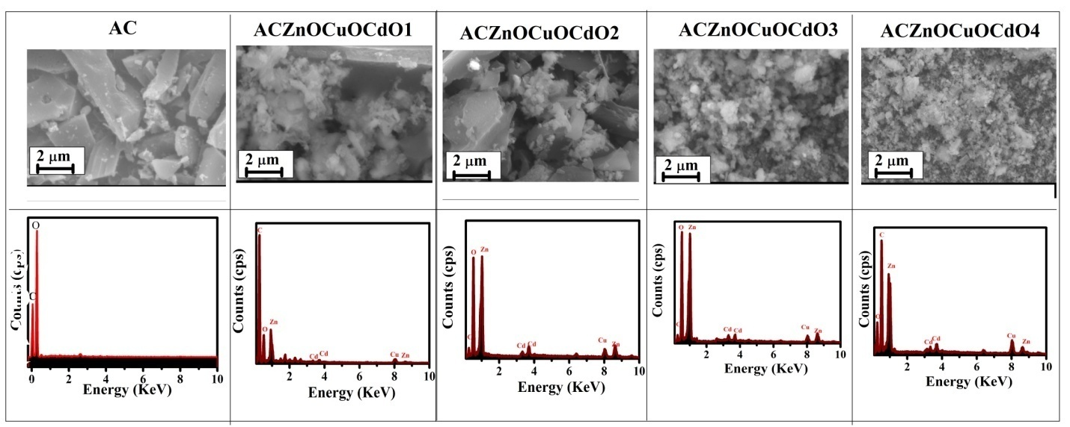

**Fig.3.SEM and EDAX spectra of (a) AC , (b) AC/ZnO/CuO/CdO1, (c) AC/ZnO/CuO/CdO2, (d) AC/ZnO/CuO/CdO3 and (e) AC/ZnO/CuO/CdO4**

**4.Conclusion**   
Activated carbon (AC) loaded with ZnO, CuO, and CdO was shown, and its effectiveness in photocatalytically breaking down phenol in the presence of natural sunshine was examined. ZnO/CuO/CdO integration onto the AC support increased the photocatalytic efficiency in visible light from natural sunshine as compared to pure metal oxides. Further, when exposed to ambient sunlight, the doped AC structure skillfully suppressed the recombination of photogenerated electron-hole pairs.

**5. References**

*1.Sedlak, D. (2014). Water 4.0: The Past, Present, and Future of the World? S Most Vital Resource. Yale University Press.*

*2.Phuruangrat, A., Thongtem, T., & Thongtem, S. (2009). Microwave-assisted synthesis of ZnO nanostructure flowers. Materials Letters, 63(13-14), 1224-1226.*

*3. Mazumder, N. A., & Rano, R. (2018). Synthesis and characterization of fly ash modified copper oxide (FA/CuO) for photocatalytic degradation of methyl orange dye. Materials Today: Proceedings, 5(1), 2281-2286.*

*4. Kaviyarasu, K., Manikandan, E., Paulraj, P., Mohamed, S. B., & Kennedy, J. (2014). One dimensional well-aligned CdO nanocrystal by solvothermal method. Journal of alloys and compounds, 593, 67-70.*